**Cereal Analysis Based on Ratings By Using Machine Learning Techniques With IBM Watson**

**Mini Project Report**

Submitted By

**(BATCH NO: CSE_002)**

BAJJURI ANUHYA(18UK1A0505)

SINDHU MECHINENI(18UK1A0552)

DENGU AJAY (18UK1A0570)

JULURI VAMSHI (18UK1A0577)

**INDEX**

**TITLE PAGE NO**

**CHAPTER 1: INTRODUCTION 3**

* 1. OVERVIEW **3**
  2. PURPOSE **3**

**CHAPTER 2: LITERATURE SURVEY 3-4**

* 1. EXISTING PROBLEM **3**
  2. PROPOSED SOLUTION **4**

**CHAPTER 3: THEORTICAL ANALYSIS 4-5**

3.1 BLOCK DIAGRAM **4**

3.2 HARDWARE/SOFTWARE DESIGNING **5**

**CHAPTER 4: EXPERIMENTAL INVESTIGATIONS 5-6**

**CHAPTER 5: FLOW CHART 6**

**CHAPTER 6: RESULTS 7-8**

**CHAPTER 7: ADVANTAGES AND DISADVANTAGES 9**

**CHAPTER 8: APLLICATIONS 9**

**CHAPTER 9: CONCLUSION 9**

**CHAPTER 10: FUTURE SCOPE 9**

**CHAPTER 11: BIBILOGRAPHY 9**

**CHAPTER 12:APPENDIX 10-14**

**CHAPTER 1**

**INTRODUCTION**

**Overview:**

A customer wants to buy some food items with high dietary benefits so that he wants to know which food item has high dietary benefits. It is so difficult to choose an item .Usually a customer expects to consume dietary cereals with high proteins, fibre and low sugars, fats. Predicting a brand with high dietary cereals became a big issue.

The project objective is to find the high dietary food that is predicted on the basis of rating of the food.

We use machine learning algorithms to predict the food with a high beneficiary diet. The model can predict the rating of the food more accurately by giving the inputs which are the cereals and ingredients present in the food. Let’s understand the data we’re working with and give a brief overview of features present.

* 78 rows with 16 columns
* Name
* mfr,
* type,
* calories,
* protein,
* fat,
* sodium ,
* fiber ,
* Carbo,
* sugars,
* potass,
* vitamins,
* shelf,
* weight,
* cups,
* Rating

**1.2 Purpose:**

By Cereal Analysis Based on Ratings by Using Machine Learning Techniques on IBM Watson we will:

1. Know fundamental concepts and can work on IBM Watson Studio.
2. Gain a broad understanding of Binary Classification.

**CHAPTER 2**

**LITERATURE SURVEY**

* 1. **Existing Problem:**

The project objective is to find the high dietary food that is predicted on the basis of rating of the food.   
 1. To find which quantities are showing more impact on the rating of food.

2. To show the food which is impacting less on the rating of food.

* 1. **Proposed Solution:**

We use machine learning algorithms to predict the food with a high beneficiary diet. The model can predict the rating of the food more accurately by giving the inputs which are the cereals and ingredients present in the food. Thus a customer can get high dietary food by the rating of the food given to it from the cereals and ingredients present.

**CHAPTER 3**

**THEORTICAL ANALYSIS**

**3.1 Block Diagram:**

|  |
| --- |
|  |

|  |
| --- |
|  |

|  |
| --- |
|  |

|  |
| --- |
|  |

**3.2 Hardware/software designing:**

**Software specifications:**

# 

|  |  |
| --- | --- |
| **REQUIREMENT** | **SPECIFICATION** |
| Anaconda Navigator | You must have anaconda installed in your device prior to begin. |
| Spyder, Jupyter Notebook, Flask  Frame work | 1. One should have Spyder and Jupyter notebook. 2. One should install flask framework through anaconda prompt for running their web application 3. We need to build the model using jupyter notebook with all the imported packages. |
| Web browser | For all Web browsers, the following must be enabled:   * cookies * JavaScript |

**Hardware Specifications:**

|  |  |
| --- | --- |
| **REQUIREMENT** | **SPECIFICATIONS** |
| Operating system | Microsoft Windows  UNIX  Linux® |
| Processing | Minimum: 4 CPU cores for one user. For each deployment, a sizing exercise is highly recommended. |
| RAM | Minimum 8 GB. |
| Operating system specifications | File descriptor limit set to 8192 on UNIX and Linux |
| Disk space | A minimum of 7 GB of free space is required to install the software. |

**CHAPTER 4**

**EXPERIMENTAL INVESTIGATIONS**

Analysis or the investigation made while working on the solution:

While working on the solution we investigated on what are cereals and their Ratings, IBM cloud, IBM Watson studio, Machine Learning service, Cloud Object Storage. The key role on investigation is collection of dataset.

**IBM Cloud Account**:

IBM Acquired soft layer, a public cloud platform, to serve as the foundation for its IaaS offering. In October 2016, IBM rolled the soft layer brand under its Blue mix brand of PaaS offerings, giving users to access both IaaS and PaaS resources from a single console. IBM cloud provides a full-stack, public cloud platform with various products in the catalog, including options for compute, storage, networking, end to end developer solutions for app development, testing and deployment, security databases, and cloud native services.

Creating the IBM cloud account by going to the IBM cloud login page and click create on IBM cloud account. Enter our IBM id and an ID is created based on the email that we enter. Completing the remaining fields with our information and click create account by this the account is created.

**Dataset preprocessing**:

The data preprocessing on Cereals is done by following steps:

* Articulate the problem early.
* Establish data collection.
* Check our data quickly.
* Format data to make it consistent.
* Reduce data.
* Complete data cleaning.
* Decompose data.
* Take the required fields of data

**CHAPTER 5**

**FLOW CHART**

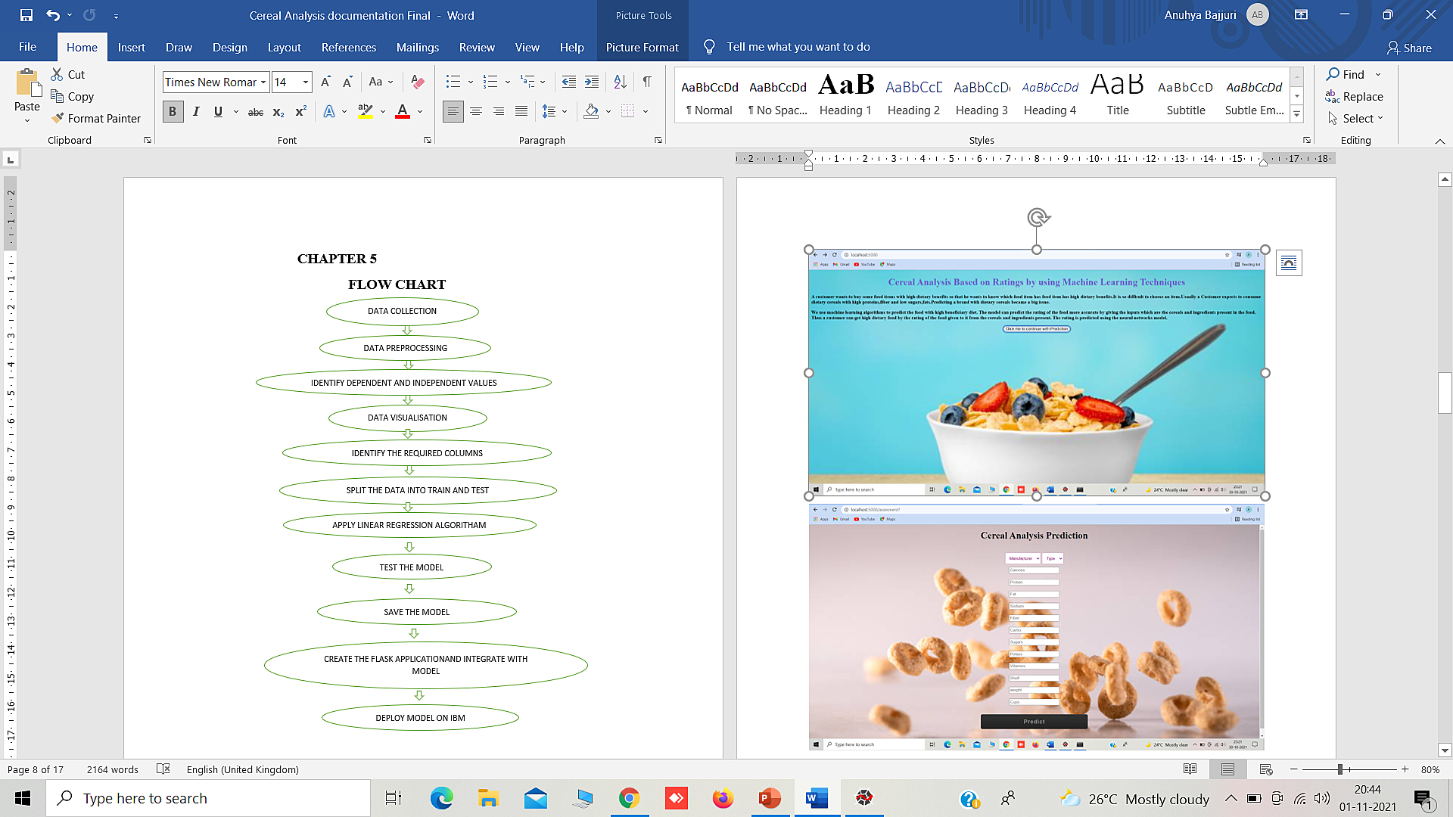

|  |
| --- |
|  |

|  |
| --- |
|  |

**CHAPTER 6**

**RESULTS**

**Final output of the project:**

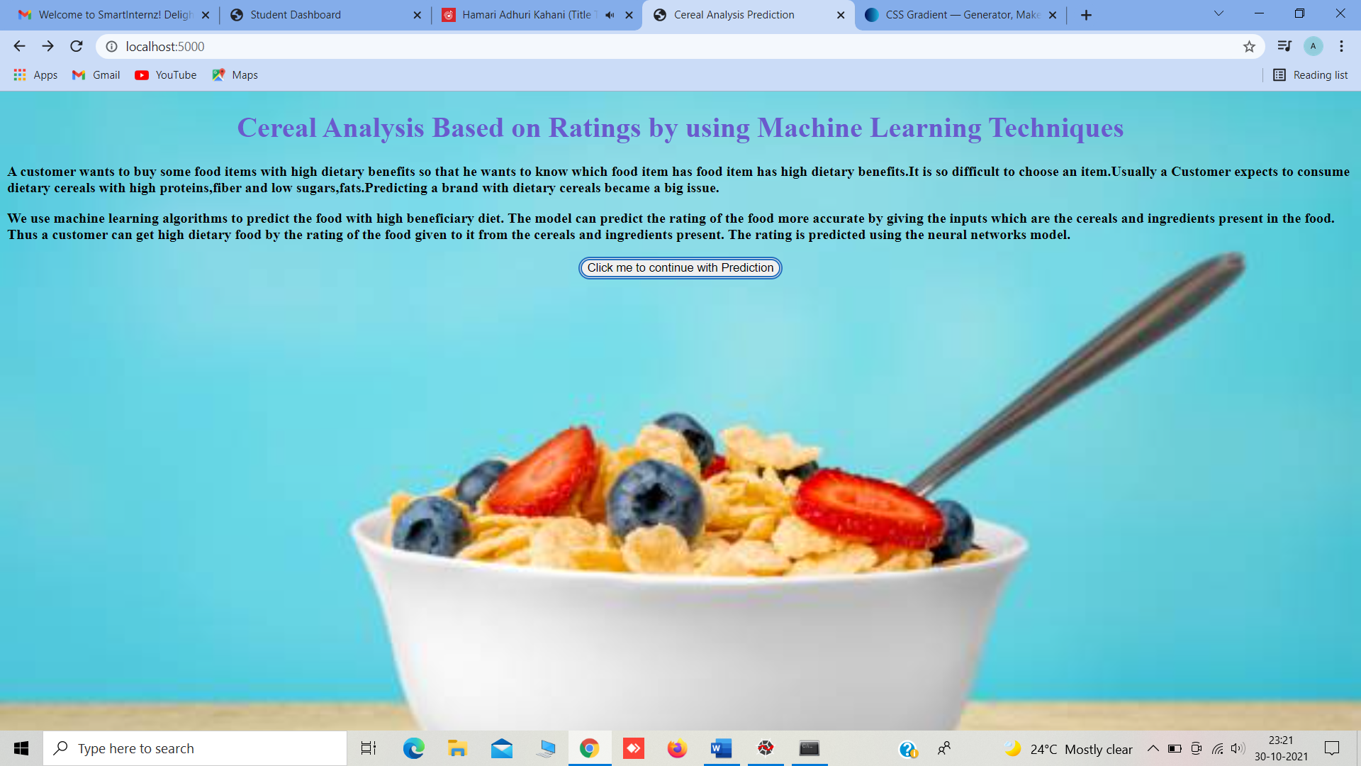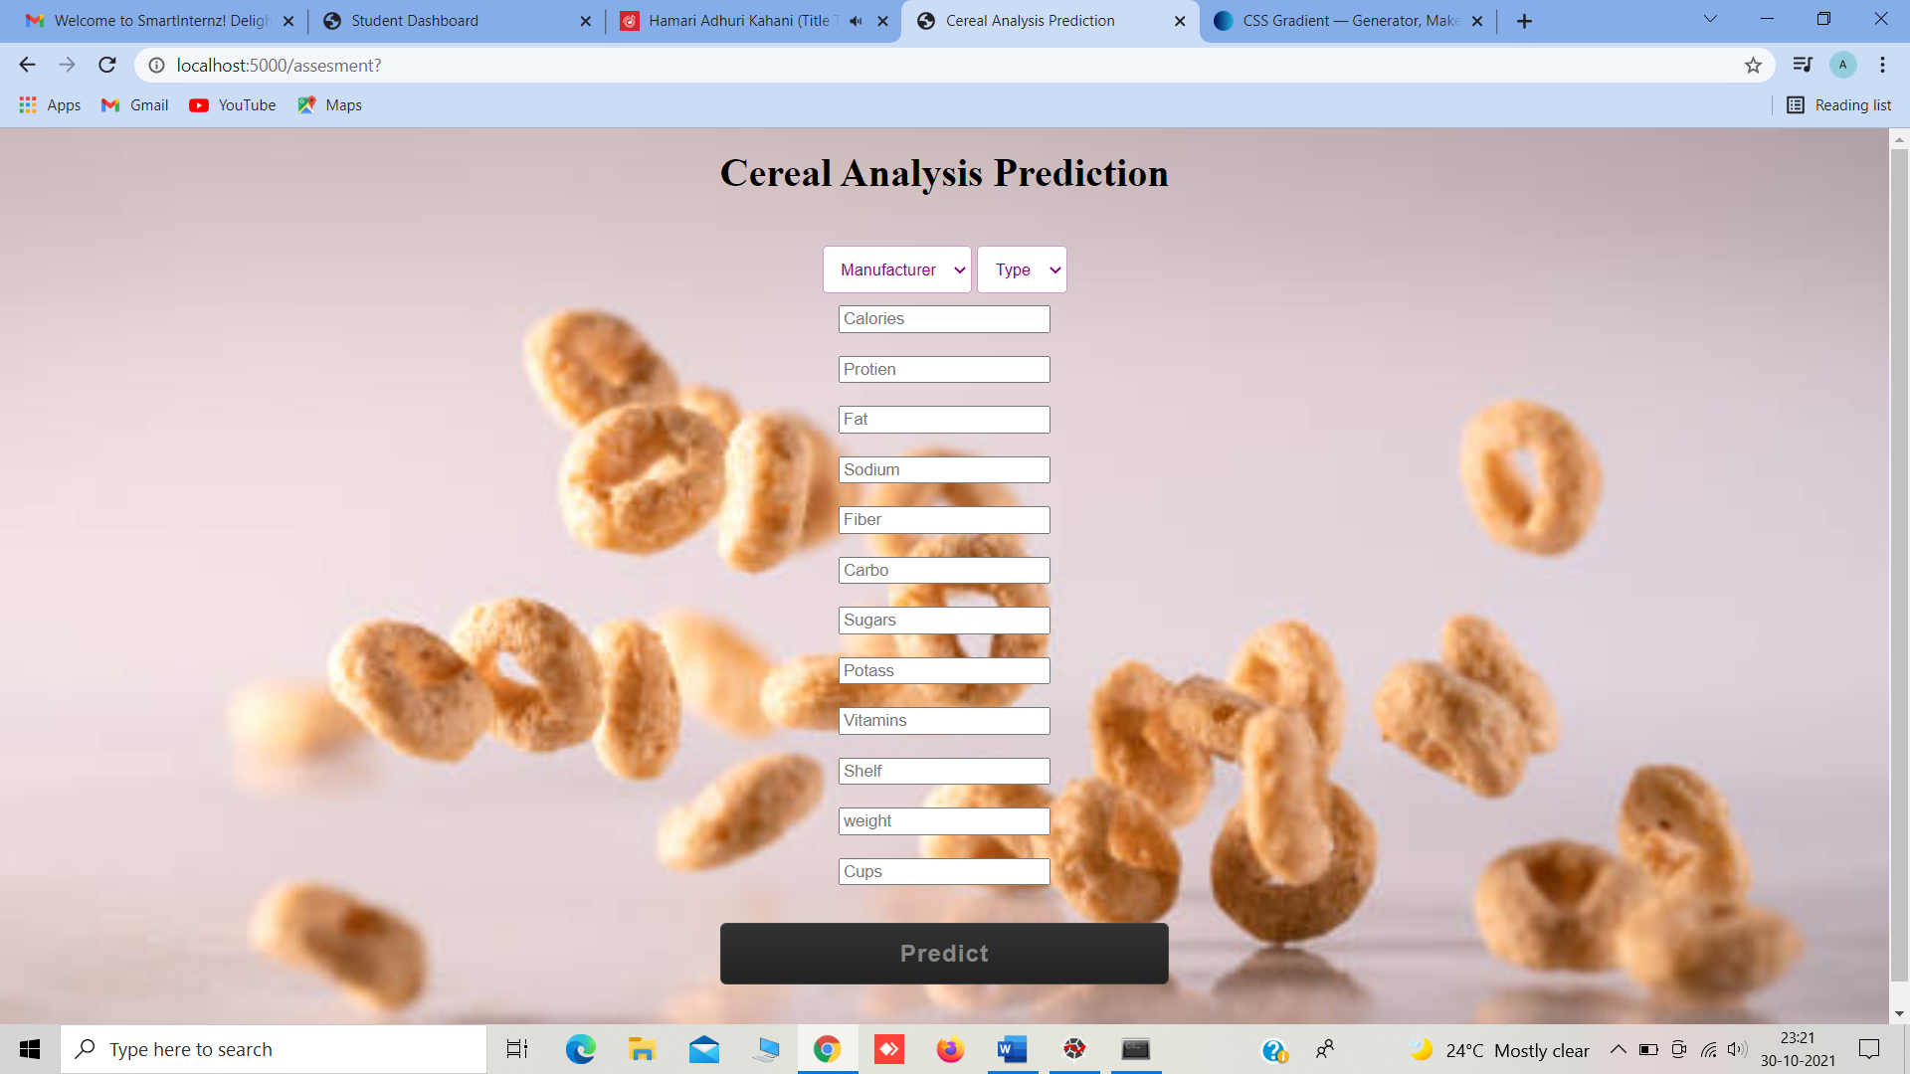

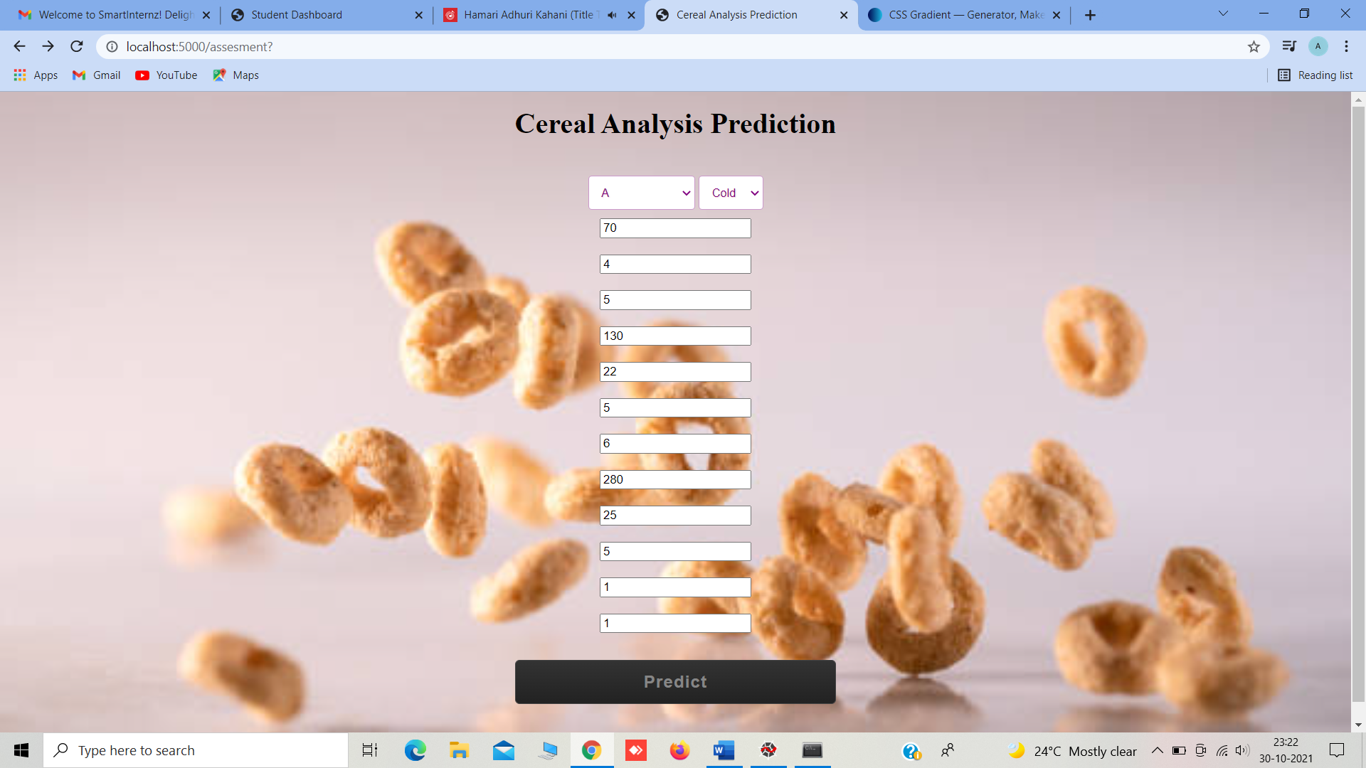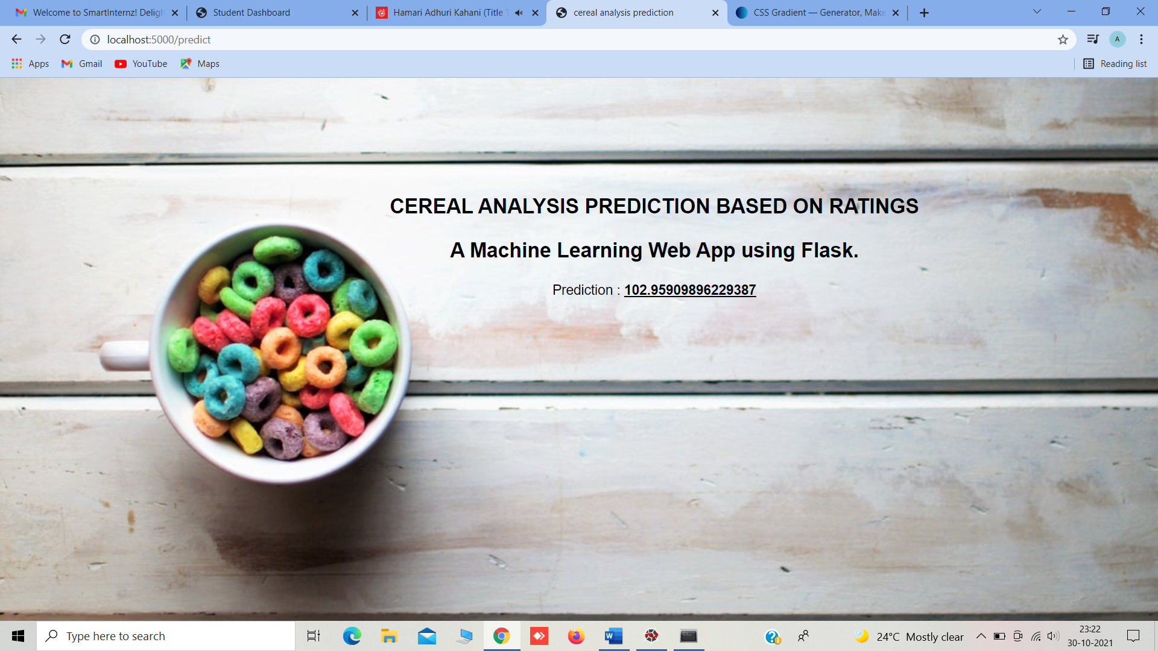

**CHAPTER 7**

**ADVANTAGES AND DISADVANTAGES**

**Advantages:**

1. Foods were grouped into categories in different ways depending on their characteristics.So every person need to composition of food they are eating, so that based the analysis it brings health conscious in them.
2. Makes every individual follow their Healthy Diet.
3. People will become Fit and Healthy,
4. Everyone will become resistant to Diseases and will be Strong.

**Disadvantages:**

1. Sometimes people may be not be able to eat what they like the most.

**CHAPTER 8**

**APLLICATIONS**

**The areas where this solution can be applied:**

1. Can be applied in each and every individual’s Daily Life.
2. Can be used by Dieticians.

**CHAPTER 9**

**CONCLUSION**

**From this entire findings we know fundamental concepts and can work on IBM Watson and machine learning.**

* Gained a broad understanding of Machine Learning algorithms.
* Learned to build stunning models on IBM cloud.
* To create data visualizations foreasy understanding.

**CHAPTER 10**

**FUTURE SCOPE**

**Enhancements that can be made in the future:**

* This model can be further developed to suggest what healthy food that should be taken by an individual. Can also enhance by adding the strict diet schedules which should be followed to be strong and fit.

**CHAPTER 11**

**BIBILOGRAPHY**

[1]Vivian P.S. Felipe, Martinho A.Silva, Bruno D.Valente..,”Using multiple regression, Bayesian networks and artificial neural networks for prediction of total egg production in European quails based on earlier expressed phenotypes”, OXFORD ACADEMIC, Adv., 2015,vol.94 [2]Saman Mohammadi, Maaroof Siosemarde, “Application of Artificial Neural Networks in Order to Predict Mahabad River Discharge” SCIENTIFIC RESEARCH, an Academic Publisher Adv., 2016.

[3] <https://www.analtyicsvidhya.com>

[4]<https://www.otexts.org/fpp/9/3>

**APPENDIX**

**base.html**

<!DOCTYPE html>

<html>

<!--From https://codepen.io/frytyler/pen/EGdtg-->

<head>

<meta charset = "UTF-8">

<title> Cereal Analysis Prediction </title>

<link rel="stylesheet" href="{{ url_for('static',filename='css/style.css')}}">

<style>

.login{

top:20X;

}

body

{

background-image:url('../static/img/predict7.jpg');

background-position: center;

font-family: Grey;

font-size:4;

font-color: Grey;

background-size: cover;

background-repeat: no-repeat;

background-attachment: fixed;

background-attachment: fixed;

background-position:20% 20%;

}

.btn-6k {

border: 4px double #226fbe;

border-radius: 15px;

font-color: #f9f9f9;

}

</style>

<body>

<div class="login">

<h1 style="color: SlateBlue;"><center>Cereal Analysis Based on Ratings by using Machine Learning Techniques</center></h1>

<span class = "label label-default"></span></h1>

<div class = "description">

<p><b>A customer wants to buy some food items with high dietary benefits so that he wants to know which food item has food item has high dietary benefits.It is so difficult to choose an item.Usually a Customer expects to consume dietary cereals with high proteins,fiber and low sugars,fats.Predicting a brand with dietary cereals became a big issue.</b></p>

<p><b>We use machine learning algorithms to predict the food with high beneficiary diet. The model can predict the rating of the food more accurate by giving the inputs which are the cereals and ingredients present in the food. Thus a customer can get high dietary food by the rating of the food given to it from the cereals and ingredients present. The rating is predicted using the neural networks model.</b></p>

</div>

<form action = "/assesment">

<center><button type="submit" class="btn btn-6 btn-6k">Click me to continue with Prediction</button></center>

</form>

</div>

</body>

</html>

**Index.html**

<!DOCTYPE html>

<html>

<!--From https://codepen.io/frytyler/pen/EGdtg-->

<head>

<meta charset="UTF-8">

<title>Cereal Analysis Prediction</title>

<link rel="stylesheet" href="{{ url_for('static', filename='css/style.css') }}">

<style>

select {

margin-bottom: 10px;

border: none;

outline: none;

padding: 10px;

color: purple;

font-size: 13px;

text-shadow: 1px 1px1pxrgb(255 182 193 / 50%);

border: 1px solid rgba(128,0,128,0.4);

border-radius: 4px;

}

body{

display: flex;

height: 100vh;

text-align: center;

align-items: center;

justify-content: center;

}

.text{

font-size: 30px;

color: #c7c7c7;

font-weight: 600;

letter-spacing: 2px;

}

form{

margin-top: 40px;

}

form .field{

margin-top: 20px;

display: flex;

}

.field .fas{

height: 50px;

width: 60px;

color: #868686;

font-size: 20px;

line-height: 50px;

border: 1px solid #444;

border-right: none;

border-radius: 5px 0 0 5px;

background: linear-gradient(#333,#222);

}

.fieldinput,form button{

height: 50px;

width: 100%;

outline: none;

font-size: 19px;

color: #868686;

padding: 0 15px;

border-radius: 0 5px 5px 0;

border: 1px solid #444;

caret-color: #339933;

background: linear-gradient(#333,#222);

}

input:focus{

color: #339933;

box-shadow: 0 0 5px rgba(0,255,0,.2),

inset 0 0 5px rgba(0,255,0,.1);

}

@keyframes glow {

0%{

border-color: #339933;

box-shadow: 0 0 5px rgba(0,255,0,.2),

inset 0 0 5px rgba(0,0,0,.1);

}

100%{

border-color: #6f6;

box-shadow: 0 0 20px rgba(0,255,0,.6),

inset 0 0 10px rgba(0,255,0,.4);

}

}

button{

margin-top: 30px;

border-radius: 5px!important;

font-weight: 600;

letter-spacing: 1px;

cursor: pointer;

}

button:hover{

color: #339933;

border: 1px solid #339933;

box-shadow: 0 0 5px rgba(0,255,0,.3),

0 0 10px rgba(0,255,0,.2),

0 0 15px rgba(0,255,0,.1),

0 2px 0 blue;

}

.link{

margin-top: 25px;

color: #868686;

}

.link a{

color: #339933;

text-decoration: none;

}

.link a:hover{

text-decoration: underline;

}

</style>

</head>

<body style="background-image:url('../static/img/fg1.jpg');background-repeat: no-repeat;background-size: cover;background-attachment: fixed;background-position:70% 50%;">

<center>

<div class="Login">

<h1>Cereal Analysis Prediction</h1>

<!-- Main Input For Receiving Query to our ML -->

<form action="/predict "method="post">

<select name="mfr">

<option disabled="disabled" selected="selected">Manufacturer</option><br>

<option value="a">A</option>

<option value="g">G</option>

<option value="k">K</option>

<option value="k">K</option>

<option value="n">N</option>

<option value="p">P</option>

<option value="q">Q</option>

<option value="r">R</option>

</select>

<select name="type">

<option disabled="disabled" selected="selected">Type</option>

<option value="c">Cold</option>

<option value="h"> Hot</option>

</select><br>

<input type="text" name="Calories" placeholder="Calories" required="required" /><br><br>

<input type="text" name="Protien" placeholder="Protien" required="required" /><br><br>

<input type="text" name="Fat" placeholder="Fat" required="required" /><br><br>

<input type="text" name="Sodium" placeholder="Sodium" required="required" /><br><br>

<input type="text" name="Fiber" placeholder="Fiber" required="required" /><br><br>

<input type="text" name="Carbo" placeholder="Carbo" required="required" /><br><br>

<input type="text" name="Sugars" placeholder="Sugars" required="required" /><br><br>

<input type="text" name="Potass" placeholder="Potass" required="required" /><br><br>

<input type="text" name="Vitamins" placeholder="Vitamins" required="required" /><br><br>

<input type="text" name="Shelf" placeholder="Shelf" required="required" /><br><br>

<input type="text" name="weight" placeholder="weight" required="required" /><br><br>

<input type="text" name="Cups" placeholder="Cups" required="required" /><br>

<button type="submit" class="btnbtn-primary btn-block btn-Large">Predict</button>

</form>

<br>

<br>

<p>

{{ z }}

<p>

</div>

</center>

</body>

</html>

**Prediction.html**

<html lang="en" dir="ltr">

<head>

<meta charset="utf-8">

<title>cereal analysis prediction</title>

<link rel="shortcut icon" href="{{ url_for('static', filename='diabetes-favicon.ico') }}">

<link rel="stylesheet" type="text/css" href="{{ url_for('static', filename='styles.css') }}">

<script src="https://kit.fontawesome.com/5f3f547070.js" crossorigin="anonymous"></script>

<link href="https://fonts.googleapis.com/css2?family=Pacifico&display=swap" rel="stylesheet">

</head>

<style>

body

{

background-image:url('../static/img/predict6.jpg');

background-position: right;

font-family:sans-serif;

background-size:cover;

background-repeat: no-repeat;

background-attachment: fixed;

font-size: 18;

}

</style>

<body>

</br></br></br></br></br></br>

<!-- Website Title -->

<div style="padding-left: 200px">

<div class="container">

<h2 class="container-heading"><span class="heading_font" ><center>CEREAL ANALYSIS PREDICTION BASED ON RATINGS</center></span>

<div class="description">

<center><p>A Machine Learning Web App using Flask.</p></center>

</div>

</div>

<!-- Result -->

<div class="results">

</div>

</div>

</body>

</html>

**app.py**

from flask import Flask, render_template, request

app = Flask (__name__)

import pickle

model = pickle.load(open('cerealanalysis.pkl','rb'))

@app.route('/')

def helloworld():

return render_template('base.html')

@app.route('/assesment')

def prediction ():

return render_template('index.html')

@app.route('/predict', methods = ['POST'])

def admin():

a=request.form["mfr"]

if (a == 'a'):

a1, a2, a3, a4, a5, a6, a7=1,0,0,0,0,0,0

if (a == 'g'):

a1, a2, a3, a4, a5,a6,a7 = 0,1,0,0,0,0,0

if (a == 'k'):

a1, a2, a3, a4, a5, a6, a7=0,0,1,0,0,0,0

if (a == 'n'):

a1, a2, a3, a4, a5, a6, a7=0,0,0,1,0,0,0

if (a == 'p'):

a1, a2, a3, a4, a5, a6, a7=0,0,0,0,1,0,0

if (a == 'q'):

a1, a2, a3, a4, a5, a6, a7=0,0,0,0,0,1,0

if (a == 'r'):

a1, a2, a3, a4, a5, a6, a7=0,0,0,0,0,0,1

b= request.form["type"]

if (b=='c'):

b=0

if (b== 'h'):

b=1

c= request.form["Calories"]

d= request.form["Protien"]

e= request.form[ "Fat"]

f= request.form["Sodium"]

g= request.form[ "Fiber"]

h= request.form["Carbo"]

i= request.form["Sugars"]

j= request.form["Potass"]

k= request.form[ "Vitamins"]

l= request.form[ "Shelf"]

m= request.form["weight"]

n= request.form["Cups"]

t=[[int (a1), int(a2), int(a3), int(a4), int(a5), int(a6), int (a7), int (b), int(c), int(d), int(e), int(f) ,int(g), int(h),int(i),int(j),int(k),int(l),int(m),int(n)]]

y = model.predict(t)

return render_template("prediction.html", z = y[0][0])

if __name__ == "__main__":

app.run(debug=True)

**new.py**

import requests

import json

# NOTE: you must manually set API_KEY below using information retrieved from your IBM Cloud account.

API_KEY = "kts70omrII5P-4S9XCV-xWlxqmQouW65uEqcB__CiWIA"

token_response = requests.post('https://iam.cloud.ibm.com/identity/token', data={"apikey": API_KEY, "grant_type": 'urn:ibm:params:oauth:grant-type:apikey'})

mltoken = token_response.json()["access_token"]

header = {'Content-Type': 'application/json', 'Authorization': 'Bearer ' + mltoken}

# NOTE: manually define and pass the array(s) of values to be scored in the next line

payload_scoring = {"input_data": [{"field": [["mfr","type","G1","G2","G3","G4","G5","G6","calories","protein","fat","sodium","fiber","carbo","sugars","potass","vitamins","shelf","weight","cups"]], "values": [[ 0. , 1. , 0. , 0. , 0. , 0. , 0. , 0. ,

100. , 2. , 1. , 140. , 2. , 11. , 10. , 120. ,

25. , 3. , 1. , 0.75]]}]}

response_scoring = requests.post('https://us-south.ml.cloud.ibm.com/ml/v4/deployments/d18d52cb-55ec-40df-9e62-b8de982c3585/predictions?version=2021-10-28', json=payload_scoring, headers={'Authorization': 'Bearer ' + mltoken})

print("Scoring response")

predictions=response_scoring.json()

print("Final Prediction:")

print(predictions['predictions'][0]['values'][0][0])